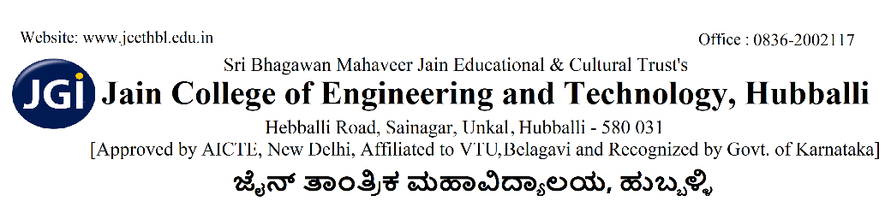
VAIBHAV 2k26
TECHNCIAL EVENTS BY CIVIL ENGINEERING DEPARTMENT
Survey Hunt – Rules & Regulations
1. Event Description
Survey Hunt is a technical treasure hunt where participants solve civil engineering and surveying-based clues and perform small field tasks using basic surveying knowledge.
2. Team Formation
- Each team must consist of 3-4 members.
- Participants must be
  - Minimum one student from Civil Engineering branch and others from different branches.
- Cross-college teams are allowed.
- Only one entry per team.
3. Event Structure
Round 1: Technical Quiz (Screening Round)
- 15–20 MCQs related to:
  - Chain surveying
  - Compass surveying
  - Levelling
  - Contouring
  - Basic calculations (RL, HI method, etc.)
- Time: 20 minutes
- Top teams qualify for Round 2.
Round 2: Survey Hunt (Field Round)
- Teams receive first clue at starting point.
- Each clue leads to a location on campus.
- At each location, teams must:
  - Solve a surveying question or
  - Perform a small task (e.g., measure distance using tape, find bearing, calculate RL).
Final Round (Optional)
- Complete a mini survey task and submit a quick calculation sheet.
4. Materials Allowed
- Scientific calculator
- Pen, pencil, scale
- Mobile phones (strictly prohibited during hunt)
- Internet usage not allowed
(If mobiles are required for QR clues, allow only camera use.)
5. Scoring Criteria
- Correct answer: 10 points
- First team to complete hunt: Bonus 10 points
- Accuracy in field task: 20 points
- Negative marking (optional): –2 for wrong answer
Winner decided based on:
- Total score
- Completion time
6. General Rules
- Participants must follow campus discipline.
- No running or damaging property.
- Clues must not be removed from locations.
- Any malpractice leads to disqualification.
- Judges’ decision is final.
7. Time Limit
- Maximum time: 60–90 minutes
- Teams exceeding time limit will be disqualified.

Faculty Coordinator: Mr. Prashanth S P [ 7406932383]
Student Coordinators: Abuzar Sagar [ 9731617630]
Suraj [9663074795]

